**Chapter-3**

1. Write the expression for a 4-input OR gate with inputs *A*, *B*, *C*, *D*, and output *X*.
2. Determine the output, *X*, for a 2-input AND gate with the input waveforms shown in Figure-1.

Show the proper relationship of output to inputs with a timing diagram. Repeat for 2 input OR gate.

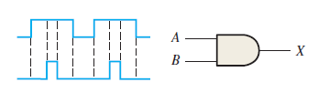Fig-1

1. The waveforms in Figure-2 are applied to points *A* and *B* of a 2-input AND gate followed by an inverter. Draw the output waveform.

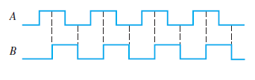Fig-2

1. Considering (Figure -2) A and B as two inputs, draw the output for 2 input OR gate, NOR gate , NAND gate, Exclusive OR , and Exclusive NOR.
2. The input waveforms applied to a 3-input AND gate are as indicated in Figure 3. Show the output waveform in proper relation to the inputs with a timing diagram. Repeat for 3 input OR gate

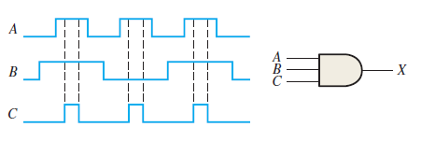Fig-3

1. The input waveforms applied to a 4-input AND gate are as indicated in Figure 4. The output of the AND gate is fed to an inverter. Draw the net output waveform of this system. Repeat for 4 input OR gate.

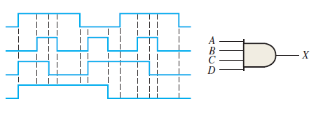Fig-4

1. For the waveforms given in Figure 5, *A* and *B* are ANDed with output *F*, *D* and *E* are ANDed with output *G*, and *C*, *F*, and *G* are ORed. Draw the net output waveform.

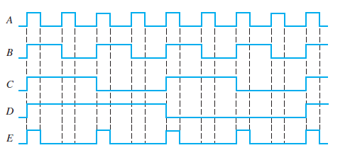Fig-5

1. Show the truth table for a system of a 3-input OR gate followed by an inverter. For the set of input waveforms in Figure 6, determine the output for the gate shown and draw the timing diagram.

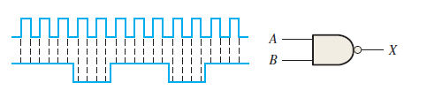Fig-6

1. Determine the gate output for the input waveforms in Figure 7 and draw the timing diagram.

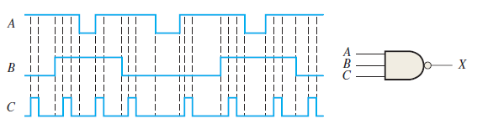Fig-7

1. As you have learned, the two logic symbols shown in Figure 8 represent equivalent operations. The difference between the two is strictly from a functional viewpoint. For the NAND symbol, look for two HIGHs on the inputs to give a LOW output. For the negative-OR, look for at least one LOW on the inputs to give a HIGH on the output. Using these two functional viewpoints, show that each gate will produce the same output for the given inputs.

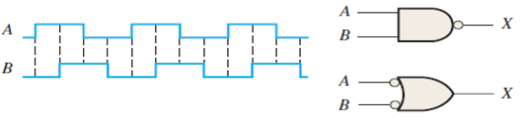Fig-8

1. Determine the output waveform in Figure 9 and draw the timing diagram.

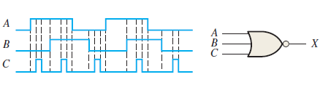Fig-9

1. The NAND and the negative-OR symbols represent equivalent operations, but they are functionally different. For the NOR symbol, look for at least one HIGH on the inputs to give a LOW on the output. For the negative-AND, look for two LOWs on the inputs to give a HIGH output. Using these two functional points of view, show that both gates in Figure 3–88 will produce the same output for the given inputs.

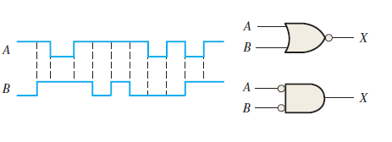Fig-10

1. How does an exclusive-OR gate differ from an OR gate in its logical operation?
2. Simplify the Boolean expressions:

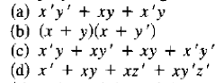

1. Simplify the Boolean expressions:

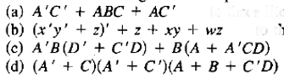

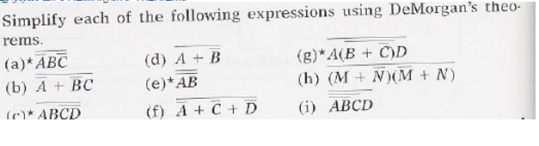

**Chapter-4**

1. Draw the logic circuit represented by each of the following expressions:
2. X= [ AB(C+D)]’
3. X = (A+B+C’DE’)’+ B’CD’
4. Draw a logic circuit for the case where the output, ENABLE, is HIGH only if the inputs, ASSERT and READY, are both LOW.
5. Draw a logic circuit for the case where the output, HOLD, is HIGH only if the input,

LOAD, is LOW and the input, READY, is HIGH.

1. Develop the truth table for each of the circuits in Figure .

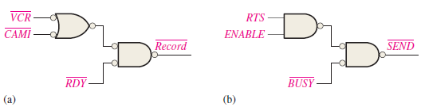

1. Define the domain of each SOP expression in above Problem convert the expression to standard SOP form.

(a) BC’ + DE(B’C + DE) (b) BC’(C’D’ + C) (c) B’+ C[B’D’ + (C’ + D )E’ ]

1. Develop a truth table for each of the following standard SOP expressions:

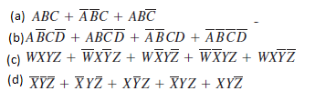

1. Develop a truth table for each of the standard POS expressions:

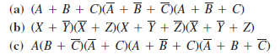

1. For each truth table in Table, derive a standard SOP and a standard POS expression.

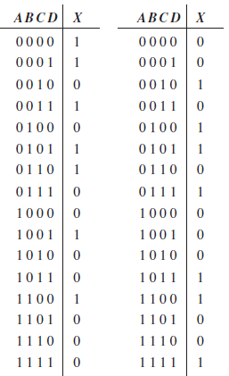

1. Use a Karnaugh map to find the minimum SOP form for each expression:



1. Use a Karnaugh map to simplify each expression to a minimum SOP form:



1. Use a Karnaugh map to simplify each expression to a minimum SOP form:

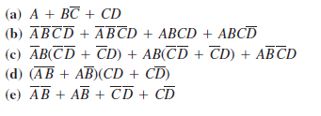

1. Use a Karnaugh map to simplify each Boolean functions.

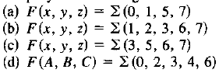

1. Use a Karnaugh map to simplify each Boolean functions.

